**C:\Users\thill\AppData\Local\Microsoft\Windows\Temporary Internet Files\Content.IE5\A1E66PDI\MC900365368[1].wmfYEAR 7Y NETBALL**

**OPPONENTS: ST PAULS**

**DATE: TUESDAY 24TH JANUARY**

**VENUE home**

**MEET: 3.05 IN CHANGING ROOMS**

**(3.50 START ISH )**

**FINISH: 5.00**

**DETAILS: FRIENDLY**

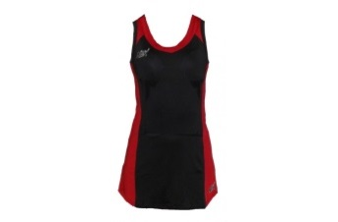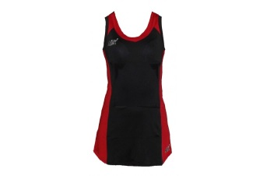**TEAM:**

**WD: CALYPSO THOMAS/ MARTHA RAYNER**

**WA: ABBIE BROWNE/ ISSY PEARCE**

**GA: EMILY FORBES (CAPT)/ MEGAN GEAR**

**GK: JEMIMA GOLDSMITH/ EMILY HOLMES**

**Please see Ms Brewington urgently if you are unable to play!**

**PLEASE TICK TO SHOW YOU CAN PLAY**

**GD: IMOGEN COLLINS/ TABITHA WARREN**

**C: GRACIE WELLER**

**C**

**GS: EMMA HARVEY/ LUCY BALCOMBE**

**To**