**C:\Users\thill\AppData\Local\Microsoft\Windows\Temporary Internet Files\Content.IE5\A1E66PDI\MC900365368[1].wmfYEAR 7A NETBALL**

**OPPONENTS: GILDREDGE HOUSE**

**DATE: TUESDAY 15TH NOV**

**VENUE: HOME**

**MEET: 3.05 IN CHANGING ROOMS**

**FINISH: 5.00**

**IN THE SPORTS HALL**

**DETAILS: FRIENDLY**

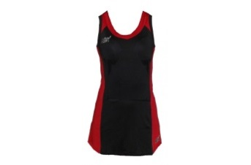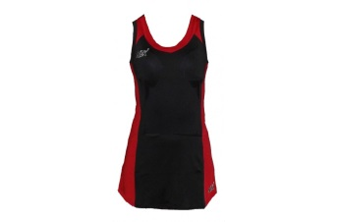**TEAM:**

**GD: LOLA COLEMAN**

**PART OF THE SQUAD AND WILL PLAY**

**FREYA HANCOCK**

**GK: BETH BROCKWELL**

**C: EMILY HARRIS**

**C**

**WA: SOPHIE HARRIS (CAPT)**

**Please see Ms Brewington urgently if you are unable to play!**

**PLEASE TICK TO SHOW YOU CAN**

**WD: LOLA BOUABSA MARRIOTT**

**GA: ROSIE FENTON**

**GS: SASHA TWIGGE MOLECY**

**To**