**C:\Users\thill\AppData\Local\Microsoft\Windows\Temporary Internet Files\Content.IE5\A1E66PDI\MC900365368[1].wmfYEAR 7A NETBALL**

**OPPONENTS: BLATCHINGTON MILL**

**DATE: THURSDAY 24TH NOVEMBER**

**VENUE: AWAY**

**MEET: 3.05 IN CHANGING ROOMS**

**HOME: 5.15**

**We will travel in the minibus there and back**

**DETAILS: CUP MATCH**

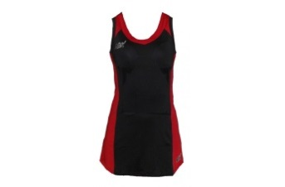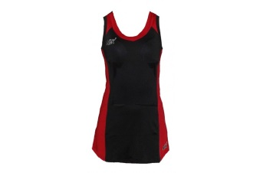**TEAM:**

**GD: LOLA COLEMAN**

**GK: BETH BROCKWELL**

**C: EMILY HARRIS**

**C**

**WA: SOPHIE HARRIS**

**Please see Ms Brewington urgently if you are unable to play!**

**PLEASE TICK TO SHOW YOU CAN**

**WD: LOLA BOUABSA MARRIOTT (CAPT)**

**GA: ROSIE FENTON**

**GS: SASHA TWIGGE MOLECY**

**To**