**C:\Users\thill\AppData\Local\Microsoft\Windows\Temporary Internet Files\Content.IE5\A1E66PDI\MC900365368[1].wmfYEAR 8b NETBALL LEAGUE**

**OPPONENTS: Cardinal Newman**

**DATE: Thursday 20th Oct**

**VENUE: Away @ Cardinal Newman**

**MEET: 2:55pm**

**HOME: 5:00pm**

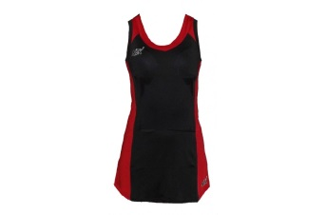**TEAM:**

**GS: Anna Bazeley**

**C: Kiana Macnamara**

**GA: Emma Logan (Captain)**

**WA: Cerelia Thompson**

**WD: Millie Haward**

**GD: Issy Cooper**

**GK: Holly Acton**

**Please see Miss Mackelworth urgently if you are unable to play!**

**To**