**C:\Users\thill\AppData\Local\Microsoft\Windows\Temporary Internet Files\Content.IE5\A1E66PDI\MC900365368[1].wmfYEAR 8 BRIGHTON CUP**

**OPPONENTS: Varndean**

**DATE: Thursday 8th December**

**VENUE: Home**

**MEET: 3:05pm**

**FINISH: 4:45pm**

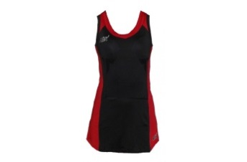

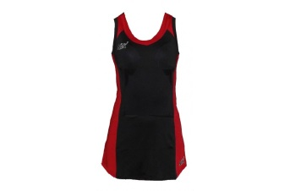**TEAM:**

**GS: Gabby Holland Villa/Maddie Edwards**

**C: Freya Hodson**

**(Captain)**

**GA: Sylvie Goodwin**

**WA: Lucy McNiven**

**WD: Fas Rooney**

**GD: Jessie Humphrey**

**GK: Courtney Freeman J**

**Please see Miss Mackelworth urgently if you are unable to play!**

**Reserve: Issy Cooper**

**To**