**C:\Users\thill\AppData\Local\Microsoft\Windows\Temporary Internet Files\Content.IE5\A1E66PDI\MC900365368[1].wmfYEAR 9 NETBALL**

**OPPONENTS: Gildredge House**

**DATE: Wednesday 16th November**

**VENUE: Home**

**MEET: 3:05pm**

**Playing in sports hall**

**FINISH: 5.00**

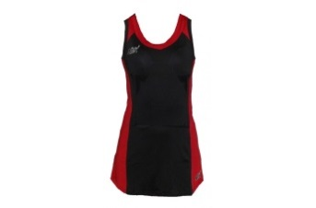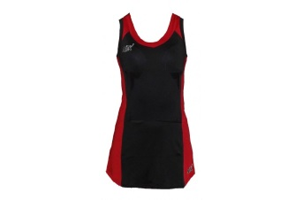**TEAM:**

**WA: Cydney Wilson/ Shea Mckinnon**

**GS: Paloma Radley Smith (Capt)/ Autumn**

**C: Rosie Lynch**

**GA: Nell Garnett**

**WD: Maddy Andrews**

**/ Aimee Farley**

**GD: Tash Barton Wells**

**GK: Autumn Grierson/ Paloma**

**Please see Ms Brewington urgently if you are unable to play!**

**To**